**OPS102 – Week 2 – File Systems - Sample Lab**

Student Name: <Abisek Gurung>

Student ID: < 135741239>

Please refer to File System Basics lecture slides for this lab

**Activity 1: File System Hierarchy**

Task 1: Login to your matrix account and list folders in root directory and show the screenshot here. (Your login prompt should be visible in the screenshot)

Task 2: Repeat Task 1 for your home directory and show the screenshot here.

<screenshot here>

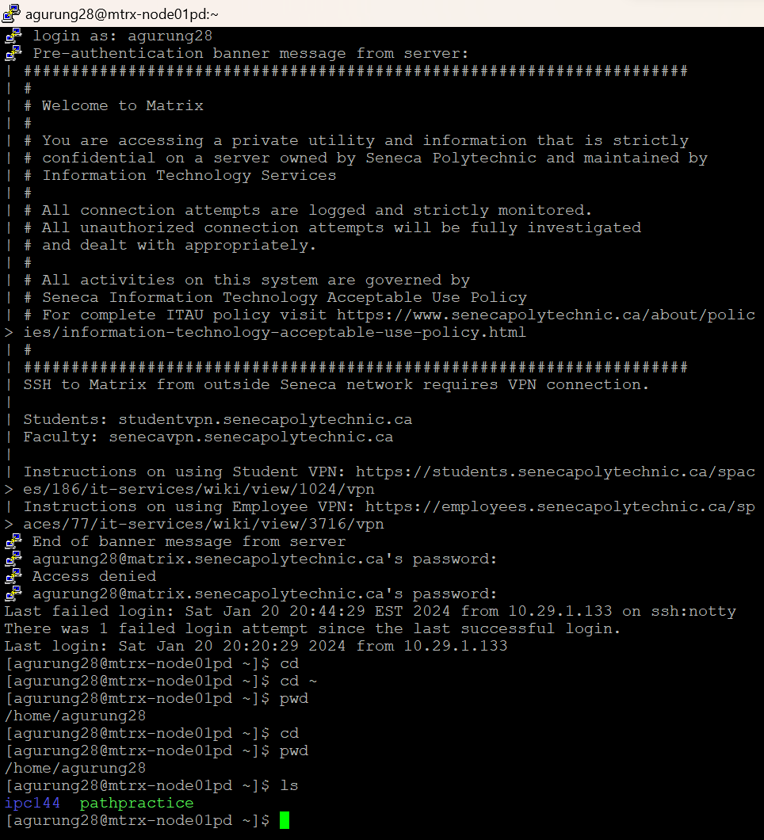

Task 3: Now login to your Windows account, open command prompt and repeat above two tasks and show screenshots here.

<screenshot here>

**Activity 2: Paths**

Consider following file hierarchy

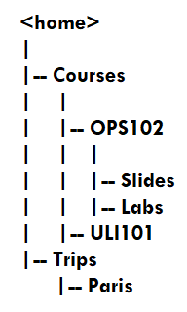

Task 1: List the absolute path of each folder shown in above image, for both Linux and Windows operating systems (You can consider this hierarchy in your home directory. Also note that absolute path starts from root directory (/) on Linux and (C:) on Windows) (you don’t need to use terminal or command prompt for these tasks, you can just type the paths):

Absolute Paths on Linux:

<list here>

=/home

= /home/course

=/home/course/OPS102

= /home/Courses/OPS102/Slides

= /home/Courses/OPS102/Labs

= /home/Courses/ULI101

= /home/Trips/Paris

Absolute Paths of Windows:

<list here>

=C:\\Courses\OPS102\Slides

=C:\Users\gurun\HOME\Courses\OPS102\Labs

=C:\Users\gurun\HOME\Courses\ULI101

=C:\Users\gurun\HOME\Trips\Paris

Task 2: List relative-to-home paths for “Slides” and “Labs” folders on Linux

<list here>

= ~/OPS102/Slides

= ~/OPS102/Labs

**Activity 3: Creating Directories**

Consider again the above folder hierarch:



Task 1: On your matrix account use “ls” command in your home directory to show that above file hierarch does not exist:

<Screenshots>

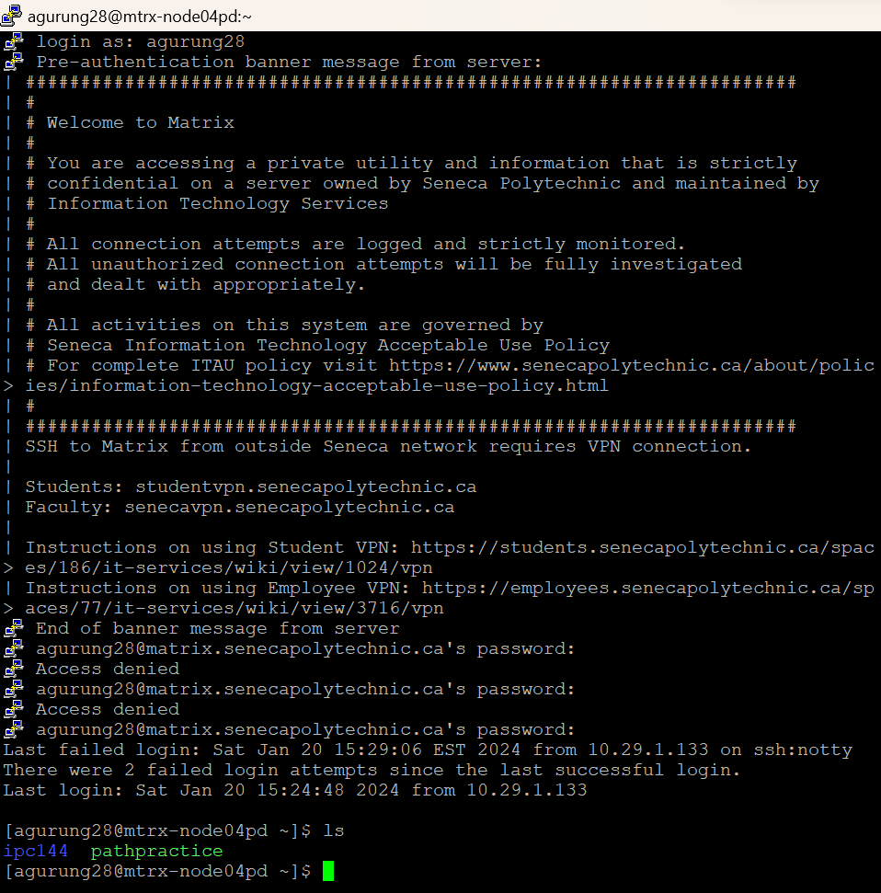

Task 2: You “mkdir” command to create above hierarchy in your home directory, creating one folder at a time. After creating all the hierarchy take one screenshot to show all executed commands.

<Screenshots>

Task 3: Repeat above two tasks for Windows using command prompt and show the screenshots below.

<Screenshots>

**Activity 4: File and Directory Operations**

Task 1: On your matrix account “cd” to “Courses” directory and execute “ls” command, then use touch command to create following files in this (“Courses”) directory:

Week1.txt

Week2.txt

Execute “ls” command again to show that these files have been created. Take a Screenshot of commands and add below

Task 2: Use “cp” command to copy above two new files to the “Slides” folder shown in above file hierarch in Activity 3, and take a screenshot:

Task 3: Use “mv” command to move “Week1.txt” and “Week2.txt” files to “Labs” folder. (After executing this task you should have two copies of these files in “Slides” and “Labs” folders and no copy in “Courses” folder) show the screenshot of executed commands below.

<Screenshots>

Task 4: Repeat above 3 tasks for Windows using command prompt and add all screenshots below (you can use any way of creating these files in the “Courses” folder, since “touch” command does not exist on Windows).

<Screenshots>

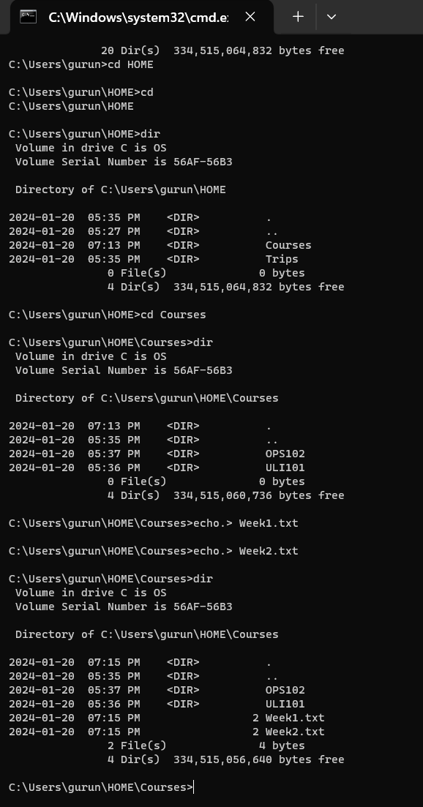

Task 5: Use “rm” command on Linux to delete the two files from both “Slides” and “Labs” folders and show the screenshots below.

<Screenshots>

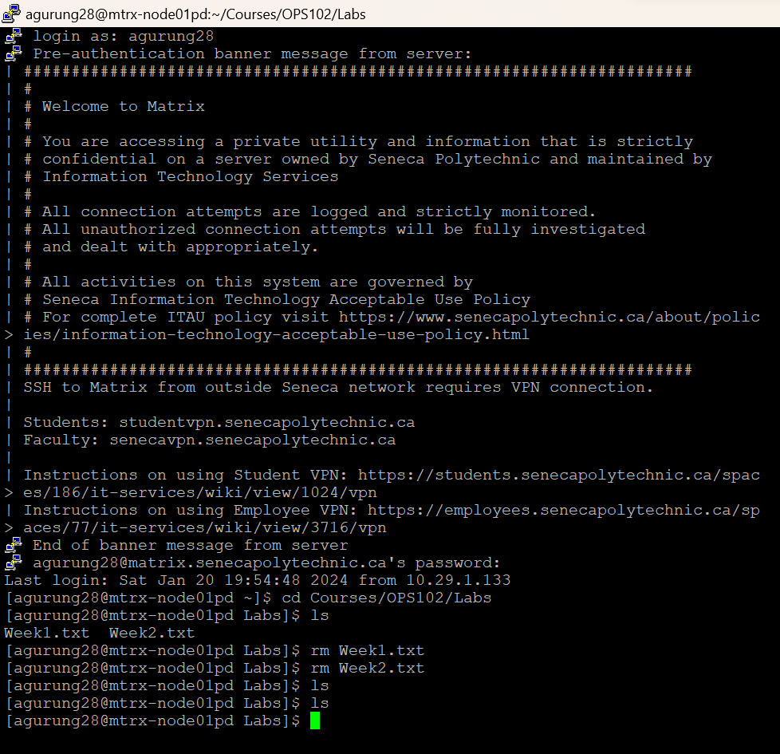

Task 6: Use “rmdir” command iteratively on Linux to delete the folder hierarchy created in Activity 3 and add screenshot below.

<Screenshots>

Task 7: Use “del” command on Winodws to delete the two files from both “Slides” and “Labs” folders and show the screenshots below.

<Screenshots>

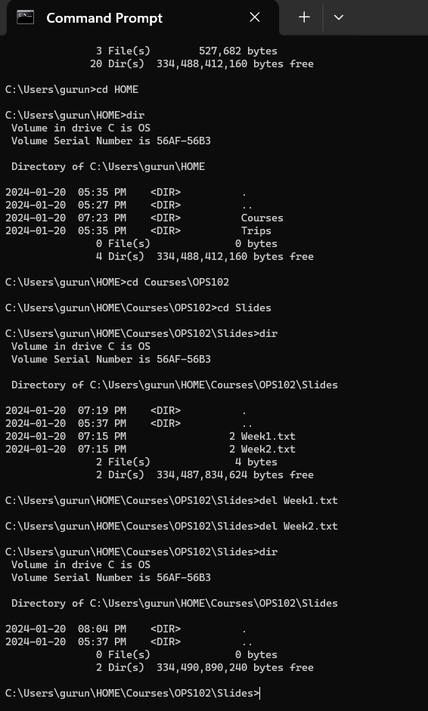

Task 8: Use “rd” command iteratively on Windows to delete the folder hierarchy created in Activity 3 and add screenshot below.

<Screenshots>

